Welcome to High Calling. This house has been given to us from the Lord and we desire to use it for His Glory. As stewards, we are all held accountable to Him. Therefore, we desire to share a few guidelines that will ensure the greatest honor to our Lord and the maximum overall benefit for everyone that will use High Calling now and in the future.

Directions to High Calling - High Calling is located about 22 miles north of Steamboat Springs, Colorado. Address: 57640 Miner’s Dream Pl, Clark CO 80428
      - Once you enter Steamboat, take highway 40 north to County Road #129. (There is a 7-11 at the corner.)
      - Turn Right and go North on County Road #129 (Elk River Road) approximately 21 ½ miles. (You will pass Clark, CO – Post Office and General Store – and a bridge about ½ mile north of Clark. DO NOT veer to the right after the bridge, on Seed House Road)
      - As you begin up the hill, you will notice houses on the left side of the road.
      - Take the FIRST right turn, Miner’s Dream Drive. (The overhead sign reads “Willow Creek Pass Village.”)
      - Take the first right turn; High Calling is the first house on the left.

**PLEASE park in the driveway and NOT on the road so as not to impede traffic or snow removal.

In Case of Emergency – First pray. The phone at High Calling is disconnected. Some cell phones have coverage and some don’t. (We know T-Mobile has service in Steamboat Springs but probably not at High Calling. Also, we have been told that Verizon, ATT/Cingular and Sprint mobile do work great here.) There is a pay phone at the general store in Clark. The closest neighbors are Kathleen Titus (970-879-5898) and Larry and Brenda Rupnow (970-879-8272). (See Map.) People may contact you through the place where you rent ski equipment.

High Calling

If you’d like to check out some pictures of High Calling and/or add some after you’ve stayed, please check out: http://highcalling.shutterfly.com/

What is at High Calling –

KITCHEN - pots, pans, coffee maker, microwave, all appliances, electric griddle, toaster, pop corn popper, crock pot, dishes, and stainless steel flatware for 12.

LINENS – to fit 1 King-sized bed; 2 Queen-sized beds; 3 twin sized beds (two bunk and one trundle) and towels.

LIVING ROOM – pull out sleeper sofa, games in closet on the stairs, topographical maps, star charts, and binoculars on the shelves. There is a radio that plays Tapes and CDs, but there is NO television.

DOWNSTAIRS – Ping pong table, cross country skis, snowshoes, and sleds.

What to Bring – Below is a suggested list of items to bring to High Calling:
  - Food sufficient for your stay (things are expensive in town, so bring what you can.)
  - Paper Towels
  - Toilet Tissue
  - Aluminum Foil
  - Lotion (it is VERY DRY)
  - Laundry and dishwasher soap (bring a small amount from home)
  - Audio Tapes and/or CDs
  - Large Trash Bags
  - D-Con for mouse control (optional, but donations are appreciated)

You may shop for groceries in Steamboat Springs at either Safeway or City Market. The general store in Clark has limited groceries and prices are understandably higher.

For shorter stays, you may choose to bring a sleeping bag and towels so you don’t have to wash linens.

What NOT to Bring – As a courtesy to others using High Calling please do NOT bring the following:
Pets (Family has allergies)
More than 12 guests at a time
More than 5 cars at a time (more will not fit in the driveway and blocks road for neighbors)
What to Do – While at High Calling you can:
  - Have devotional and Bible Study time
  - Ski or shop in Steamboat
  - Enjoy the wildlife and stargaze
  - Get an Ice cream cone at the Clark general store
  - Snowshoe or sled, play a game, or play ping pong!

When You Arrive –
      - In the garage on the south inside wall, check to see if breaker number #27 is on. This controls the 120-gallon hot water heater. If not, flip it on.
      - Adjust each individual room thermostat to desired level. (See Floor plan for location)
#1 – Garage #2 – Downstairs Bath
#3 – Utility Room #4 – Downstairs Hall
#5 – Down Stairs Bedroom #6 – Other Downstairs Bedroom
#7 – Living room and Dining Room (set at 40° when away)
#8 – Upstairs Hall #9 – Upstairs Bedroom #1 (with king-size bed)
#10 – Other Upstairs Bedroom
#11 – Under the Kitchen Sink (Leave where set, at “off”)
#12 - Under the upstairs Bathroom Sink (Leave set at 40° minimum)
      - If you wish to light a fire, please check that the flue is OPEN. When you use dry wood from the garage, please replace it with wood from outside so it is ready for the next guests. There is ABSOLUTELY NO BURNING OUTSIDE, except for the grill.
      - The house is heated electrically, which unfortunately is VERY expensive. Please keep all thermostats at a minimum, especially when you are away from High Calling.
When Leaving -
- Please sign the guest book, making any comments that you wish. Leave your memories that others may share your experiences.
- Bag trash to be removed by you, when you leave. You may ask a business in Steamboat for permission to leave it in their dumpster (there is a major fine for disposal to a dumpster without permission), or you may take it home and dispose of it there. THERE IS NO TRASH REMOVAL AT HIGH CALLING. PLEASE BE CONSIDERATE OF FUTURE GUESTS.
- Wash all towels and linens used and have beds ready for the next guests.
- Leave a note to the next guests to let them know of something “special” (i.e. ice cream in the freezer, etc.) Leave the note on the dining room table.
- Please clean the fireplace and close the damper. (Damper handle is a little hard to find. It is a metal rod handle just inside the top center of the large metal fireplace opening.) Please dust and clean up after yourselves for the next guests.
- Please leave the thermostats at the following settings:
#7 – Living Room/Dining Room at 50°
Minimum heat: garage, downstairs bath, utility room, and
Master bedroom #1 (these are marked with red signs)
#s 4, 5, 6, 8, 10, 11 – Off
Breaker #27 – Off, unless someone is coming in the same day.
- Return all keys.
For additional questions, please email us at TYJesus@aol.com.
We are so pleased you have chosen High Calling and we pray that you will find true joy and peace here!
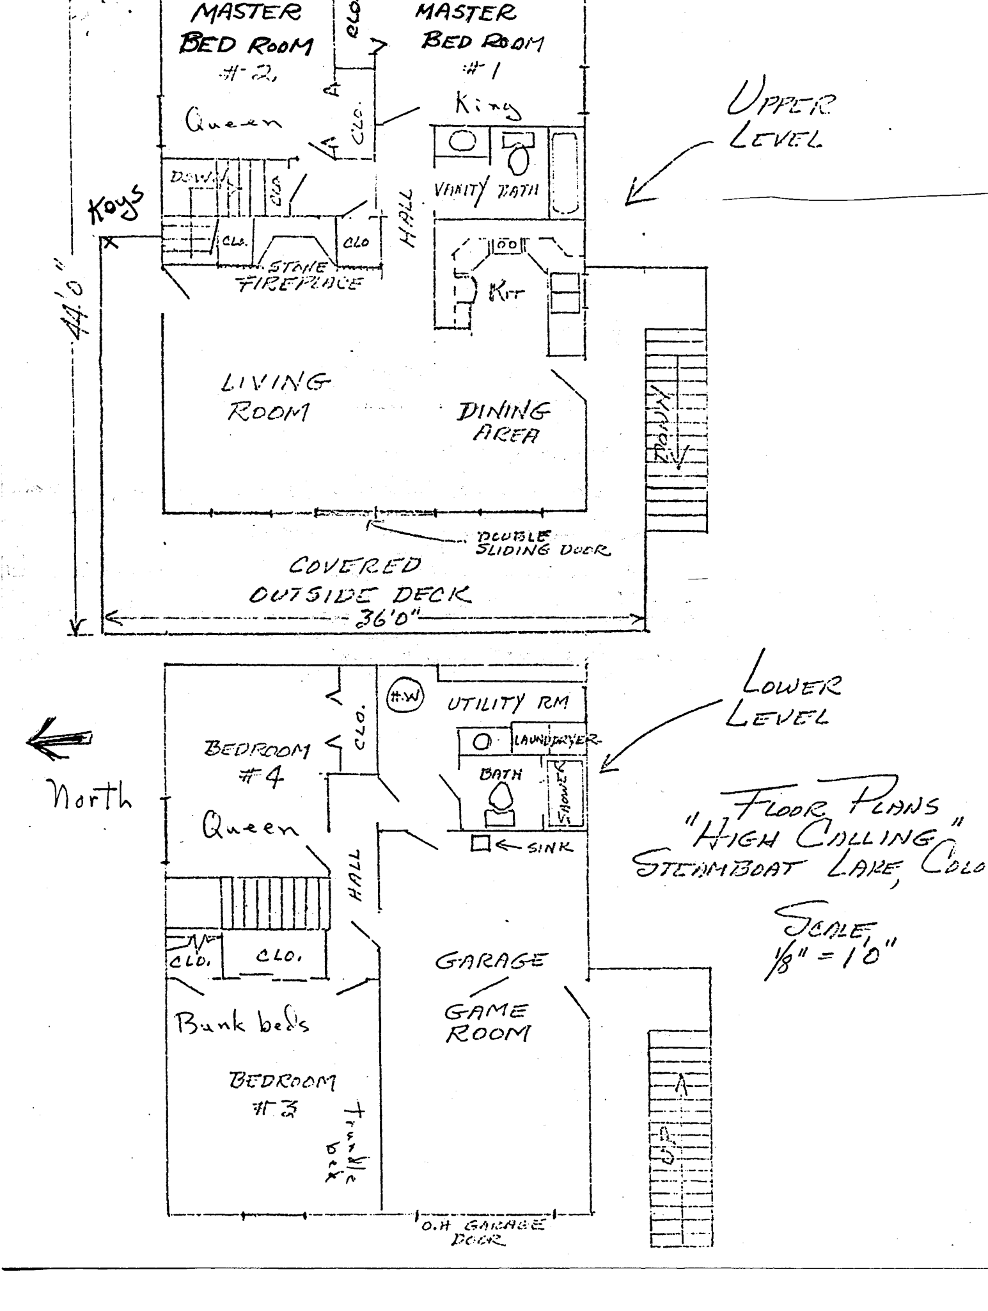

To Kremling

Highway 40

Seed House Road (Great Scenery)

High Calling

Gene and Linda Bench

Miner’s Dream Drive
Sign Says:
Willow Creek Pass Village
Clark Store
(payphone)
and Post Office
Glen Eden Restaurant

About 18 miles

About 3 ½ miles
miles
This map is NOT to scale
Steamboat Springs

Kathleen Titus

Ski area

